

Practicum Report

**“Human Brain Activity Classification”**

Under the Guidance

of

Dr. Monika Bansal

Submitted By:

Utsav Singhal, 02917711622, AIML-A

Saarthak Bansal, 03917711622, AIML-A

Chakshu Gupta, 05817711622, AIML-A

Dhairya Goel, 06117711622, AIML-A

**DECLARATION**

This is to certify that Practicum Report titled “**Human Brain Activity Classification**”,

for the Practicum course with AIML260 is submitted by Utsav Singhal, 02917711622, AIML-A Saarthak Bansal, 03917711622, AIML-A ,Chakshu Gupta, 05817711622, AIML-A, Dhairya Goel, 06117711622, AIML-A in partial fulfillment of the requirement for the award of degree B.Tech. in Artificial Intelligence and Machine Learning, VIPS-TC, GGSIP University, Dwarka, Delhi. It comprises of our original work. The due affirmation has been made within the report for utilizing the referenced work.

**Date:**

**Utsav Singhal, 02917711622, AIML-A**

**Saarthak Bansal, 03917711622, AIML-A**

**Chakshu Gupta, 05817711622, AIML-A**

**Dhairya Goel, 06117711622, AIML-A**

**Certificate by Supervisor**

This is to certify that Practicum Report titled “**Human Brain Activity Classification**” for the Practicum course with AIML260 is submitted by Utsav Singhal, 02917711622, AIML-A Saarthak Bansal, 03917711622, AIML-A ,Chakshu Gupta, 05817711622, AIML-A, Dhairya Goel, 06117711622, AIML-A in partial fulfillment of the requirement for the award of degree B.Tech in Artificial Intelligence and Machine Learning, VIPS-TC, GGSIP University, Dwarka, Delhi. It is a record of the candidates own work carried out by them under my supervision. The matter embodied in this Report is original and has not been submitted for the award of any other degree.

**Date: (Signature) Dr. Monika Bansal**

**Signature of HOD Signature of Branch Coordinator**

**Acknowledgement**

We would like to express my heartfelt gratitude to all those who have contributed to the successful completion of our practicum report. First and foremost, we would like to extend our deepest appreciation to our supervisor, Dr. Monika Bansal, for their constant guidance, valuable insights, and unwavering support throughout this journey. We are also indebted to the staff and faculty members of VIPS-TC, GGSIPU, Dwarka, Delhi, whose expertise and cooperation were instrumental in enhancing our learning experience. Additionally, we are grateful to our fellow students who provided us with invaluable feedback and encouragement.

(Signature of the students)

**Index**

|  |  |  |
| --- | --- | --- |
| **S.No.** | **Description** | **Page No.** |
| 1 | Introduction | 6 |
| 2 | Related Work | 7 |
| 3 | Problem Statement and Objectives | 8 |
| 4 | Project Analysis and Design | 9 |
| 5 | Proposed Work and Methodology Adopted | 10 |
| 6 | Results | 11 |
| 7 | Conclusion | 12 |
| 8 | Future Scope of Work | 13 |
| 9 | References | 14-16 |

1. **Introduction**

When it comes to caring for patients with neurological conditions, every moment counts. Imagine being in a hospital, where quick and accurate decisions can mean the difference between preventing harm and providing the best possible care. This is where electroencephalography (EEG) steps in as a crucial tool.EEG isn't just another medical instrument—it's like having a window into the intricate workings of the human brain, allowing doctors to monitor real-time brain activity with remarkable precision. Think of it as a guardian angel, quietly watching over patients in critical care settings, such as hospitals. With EEG recordings, healthcare professionals can uncover vital insights into neurological diseases like seizures or unusual brain activity. It's like having a detective on the case, revealing clues that help diagnose conditions and guide treatment plans tailored to each patient's needs.

In essence, EEG isn't just about data—it's about empowering caregivers to make informed decisions swiftly and confidently, ensuring that patients receive the timely attention and support they deserve. So, let's delve deeper into the world of EEG and explore how it's transforming patient care, one brainwave at a time. Epilepsy is a neurological disease characterized by rapid electrophysiological changes in the brain. More than 60 million people worldwide suffer from various types of epilepsy, especially in developing countries. Epilepsy detection is an important task in clinical research, which has stimulated extensive research into the design and diagnosis of automated seizure algorithms to develop treatment strategies. Additionally, predicting seizures may help further treatment of these patients. Scalp electroencephalography (EEG) is an important diagnostic tool for patients with epilepsy. In recent years, digital EEG monitoring systems can capture long-term EEG data of epileptic patients to identify the occurrence of abnormal events and make timely decisions. Experts detect cases of epilepsy by reading long, time-consuming electroencephalograms. Epilepsy monitoring can help professionals identify epileptic events in EEG signals.

1. **Related Work**

In the realm of neuroscience and machine learning, the focus is on understanding and addressing the critical issue of identifying and managing seizures and other hazardous patterns of brain activity. These patterns pose a significant risk to patients, increasing the likelihood of in-hospital mortality, especially when they persist for extended periods. To tackle this challenge, researchers have turned to Convolutional Neural Networks (CNNs), a deep learning architecture renowned for its ability to analyze grid-like structures, such as images. CNNs excel in pattern recognition tasks by capturing spatial relationships effectively. However, while they are adept at capturing local spatial patterns, they may struggle with the intricate spatial dynamics present in EEG signals. Despite their effectiveness, training complex CNNs can be resource-intensive, demanding substantial amounts of time and data. This poses challenges for real-life applications, particularly in low-resource environments. Nonetheless, studies have shown promising results using CNN approaches in seizure detection and classification. Researchers have explored various techniques to enhance CNN performance in EEG analysis. Some have employed transfer learning models, leveraging pre-trained CNNs to improve classification accuracy. Others have experimented with transforming EEG time series into spectrograph images to facilitate CNN-based analysis. Beyond CNNs, Recursive Neural Networks (RNNs) have emerged as another valuable tool in EEG analysis. RNNs, particularly Long Short-Term Memory (LSTM) networks, are adept at capturing temporal dependencies in sequential data. They have been successfully employed in seizure prediction and detection tasks, offering a powerful means of extracting high-level representations from EEG signals. Recent studies have demonstrated the effectiveness of LSTM models in identifying different patterns in EEG signals, showcasing their potential for both invasive and non-invasive recordings. These advancements underscore the importance of leveraging cutting-edge machine learning techniques to improve our understanding and management of neurological conditions, ultimately enhancing patient outcomes in critical care settings.

1. **Problem Statement and Objective**

Our primary objective is to develop an advanced machine learning system that utilizes EEG signals to enhance patient care in hospital settings by:

* Detecting various forms of hazardous brain activity.
* Categorizing detected abnormalities accurately and efficiently.
* Providing timely alerts to healthcare professionals regarding critical neurological distress indicators.

By building this advanced machine learning system, we aim to provide healthcare professionals with a powerful ally in their efforts to ensure patient safety and well-being. With accurate and timely detection of hazardous brain activity, we can enable quicker response times and more effective treatment strategies, ultimately improving outcomes for patients in critical care.

1. **Design Phase**
   1. **Software Requirements:**

1) Python (programming language)

2) Jupyter Notebook or JupyterLab (for interactive development)

3) IDEs (Integrated Development Environments) such as PyCharm, Spyder, or VSCode (for code development)

4) Version Control System: Git & Github (for collaborative development and version control)

**4.2 Flow Chart/Activity Diagram**

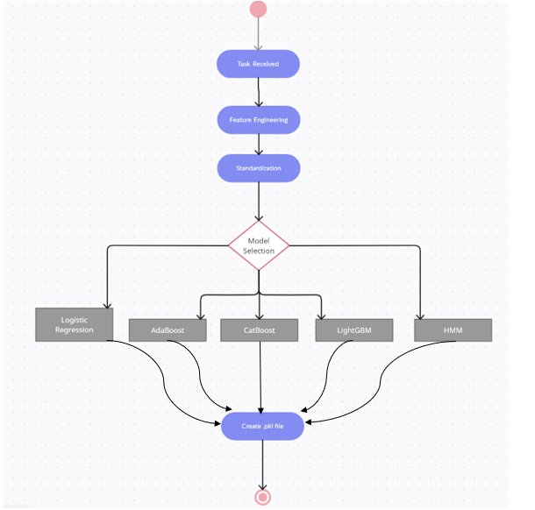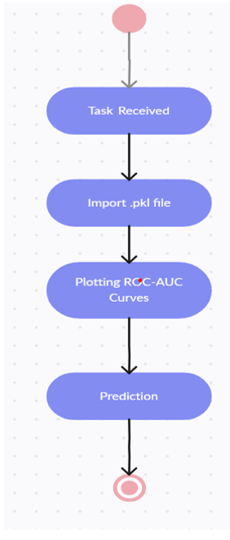

Figure I: Pre-Processing and Training Figure II: Prediction

1. **Work Done**

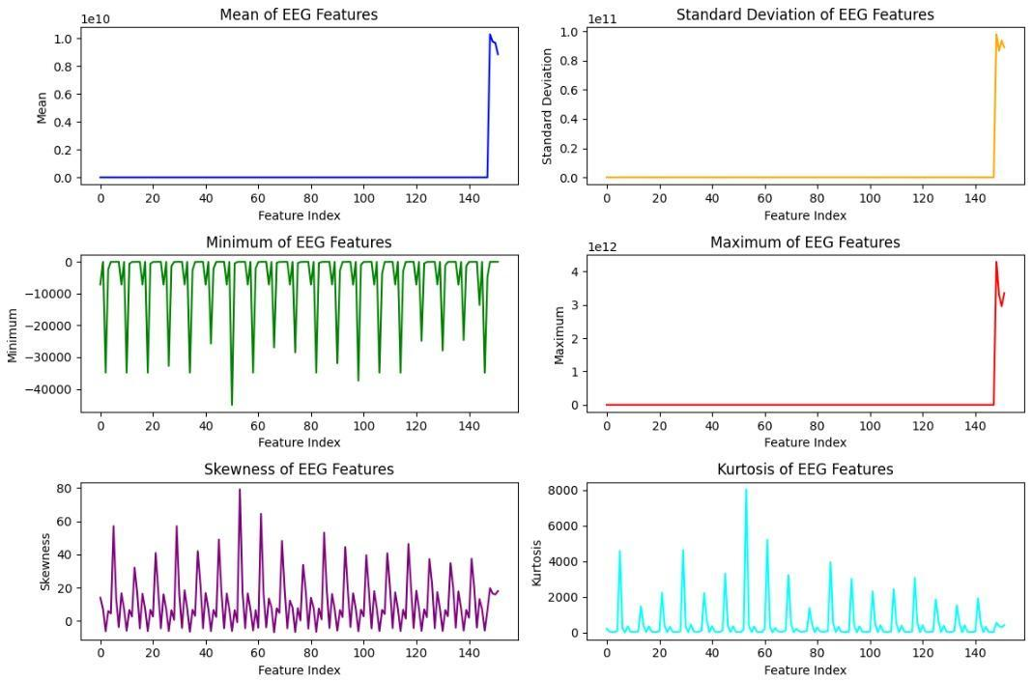

Figure III: EDA & Feature Engineering

Table I: Dataset description of given by Critical Care EEG Monitoring Research Consortium (CCEMRC)

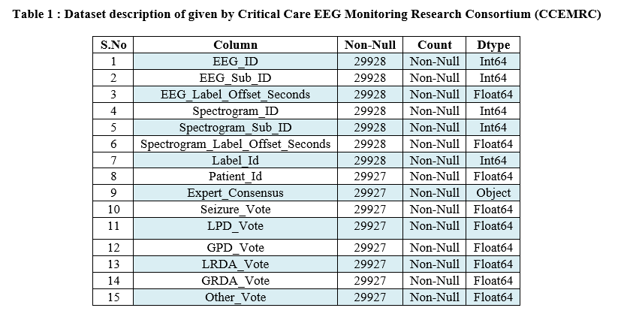

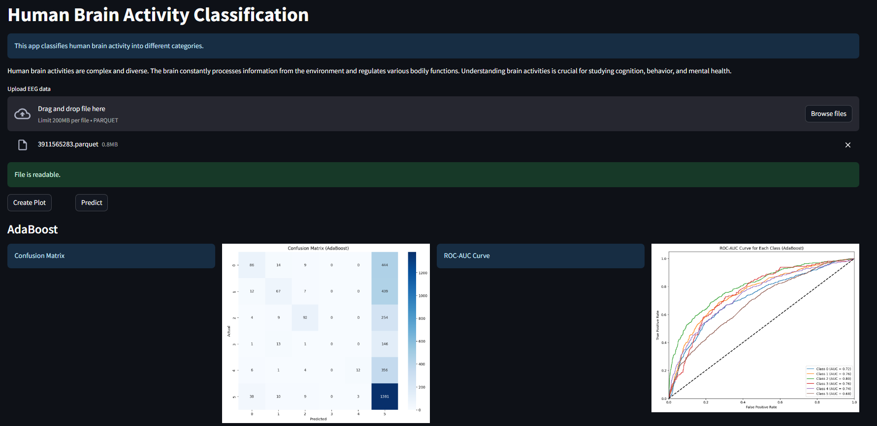

Figure IV: Frontend

1. **Results**

|  |  |  |  |  |  |  |  |  |  |  |
| --- | --- | --- | --- | --- | --- | --- | --- | --- | --- | --- |
| **Light GBM** | | | | |  | **XGBoost** | | | | |
|  | **Precision** | **Recall** | **F1-Score** | **Support** |  | **Precision** | **Recall** | **F1-**  **Score** | **Support** |
| **Seizure** | 0.59 | 0.48 | 0.53 | 553 | **Seizure** | **0.58** | **0.49** | **0.53** | **553** |
| **LPD** | 0.73 | 0.6 | 0.66 | 525 | **LPD** | **0.71** | **0.62** | **0.66** | **525** |
| **GPD** | 0.85 | 0.55 | 0.67 | 359 | **GPD** | **0.81** | **0.55** | **0.65** | **359** |
| **LRDA** | 0.73 | 0.2 | 0.31 | 161 | **LRDA** | **0.57** | **0.24** | **0.33** | **161** |
| **GRDA** | 0.66 | 0.32 | 0.44 | 379 | **GRDA** | **0.62** | **0.34** | **0.44** | **379** |
| **Other** | 0.6 | 0.86 | 0.71 | 1441 | **Other** | **0.61** | **0.84** | **0.71** | **1441** |

|  |  |  |  |  |  |  |  |  |  |  |
| --- | --- | --- | --- | --- | --- | --- | --- | --- | --- | --- |
| **CatBoost** | | | | |  | **AdaBoost** | | | | |
|  | **Precisin** | **Recall** | **F1-Score** | **Support** |  | **Precision** | **Recall** | **F1-Score** | **Support** |
| **Seizure** | **0.6** | **0.44** | **0.51** | **553** | **Seizure** | **0.59** | **0.16** | **0.25** | **553** |
| **LPD** | **0.74** | **0.58** | **0.65** | **525** | **LPD** | **0.59** | **0.13** | **0.21** | **525** |
| **GPD** | **0.84** | **0.53** | **0.65** | **359** | **GPD** | **0.75** | **0.26** | **0.38** | **359** |
| **LRDA** | **0.73** | **0.2** | **0.32** | **161** | **LRDA** | **0** | **0** | **0** | **161** |
| **GRDA** | **0.62** | **0.27** | **0.38** | **379** | **GRDA** | **0.8** | **0.03** | **0.06** | **379** |
| **Other** | **0.58** | **0.88** | **0.7** | **1441** | **Other** | **0.46** | **0.96** | **0.62** | **1441** |

Table II: Confusion Matrix

1. **Conclusion**

The study employed a "pattern recognition" approach to classify EEG signals recorded during testing and active cognitive states of consciousness. Various machine learning algorithms, including Logistic Regression, XGBoost, AdaBoost, LightGBM, and CatBoost, were utilized to classify different EEG patterns such as Seizure, Generalized Periodic Discharges (GPD), Lateralized Rhythmic Delta Activity (LRDA), Generalized Rhythmic Delta Activity (GRDA), and other patterns.

The classification results obtained from the mentioned algorithms showed variations in performance metrics including recall, precision, and F1-score. However, these results were not consistently accurate across all decomposition levels. To validate the proposed approach, experimental results were evaluated using KL Divergence Evaluation loss metrics. Despite some limitations in the study, such as the need for a larger dataset to enhance robustness and the relatively easier separation of EEG signals recorded during cognitive tasks, the findings suggest promising potential for the method's application to clinical datasets.

In summary, while the study demonstrated promising results, further research with larger datasets and consideration of additional factors are recommended for more comprehensive validation and application of the proposed method in EEG signal classification.

1. **Future Scope of Work**

The approach used in the study offers exciting possibilities for future applications in neurology and research. One potential avenue is the development of wearable devices capable of detecting seizures in real-time by analyzing EEG signals and patterns. These devices could send alerts to both patients and doctors, enabling timely intervention and treatment.

By using wearable technology combined with advanced algorithms, doctors could monitor patients remotely and accurately identify seizure events as they happen. This proactive approach could improve patient safety and help reduce the severity and duration of seizures.

Integrating cloud-based platforms for storing and accessing patients' medical histories could further enhance seizure management. By uploading and maintaining comprehensive medical records in secure cloud repositories, doctors could gain valuable insights into each patient's condition over time. This data would enable more informed decision-making, personalized treatment plans, and continuous monitoring of disease progression.

Moreover, cloud-based platforms facilitate seamless communication between patients, caregivers, and medical professionals. Patients could easily share their data with doctors, enabling remote consultations and proactive interventions based on real-time insights. This integrated approach promotes patient engagement and empowers individuals to take an active role in managing their health.

In summary, the integration of wearable devices for seizure detection and cloud-based platforms for storing medical data holds significant promise for improving patient outcomes in neurology. By leveraging advancements in technology and data analytics, healthcare providers can deliver timely interventions, personalized care, and continuous monitoring, ultimately enhancing the quality of life for individuals living with epilepsy and other neurological disorders.

1. **References**
2. Jin Jing, Zhen Lin, Chaoqi Yang, Ashley Chow, Sohier Dane, Jimeng Sun, M. Brandon Westover. (2024). HMS - Harmful Brain Activity Classification . Kaggle. https://kaggle.com/competitions/hms-harmful-brain-activity-classification
3. Jing, J., Ge, W., Hong, S., Fernandes, M. B., Lin, Z., Yang, C., & Westover, M. B. (2023). Development of expert-level classification of seizures and rhythmic and periodic patterns during EEG interpretation. Neurology, 100(17), e1750-e1762.
4. Miltiadous, A., Tzimourta, K. D., Giannakeas, N., Tsipouras, M. G., Glavas, E., Kalafatakis, K., & Tzallas, A. T. (2022). Machine learning algorithms for epilepsy detection based on published EEG databases: A systematic review. IEEE Access, 11, 564-594.
5. Scheuer, M. L., Wilson, S. B., Antony, A., Ghearing, G., Urban, A., & Bagić, A. I. (2021). Seizure detection: interreader agreement and detection algorithm assessments using a large dataset. Journal of clinical neurophysiology, 38(5), 439-447.
6. Azizi, T. (2024). Disrupted organization of dynamic functional networks with application in epileptic seizure recognition. Neuroscience Informatics, 4(1), 100153.
7. Lopez, S., Suarez, G., Jungreis, D., Obeid, I., & Picone, J. (2015, December). Automated identification of abnormal adult EEGs. In 2015 IEEE signal processing in medicine and biology symposium (SPMB) (pp. 1-5). IEEE.
8. Roy, S., Kiral-Kornek, I., & Harrer, S. (2019). ChronoNet: A deep recurrent neural network for abnormal EEG identification. In Artificial Intelligence in Medicine: 17th Conference on Artificial Intelligence in Medicine, AIME 2019, Poznan, Poland, June 26–29, 2019, Proceedings 17 (pp. 47-56). Springer International Publishing.
9. Trejo, L. J., Kubitz, K., Rosipal, R., Kochavi, R. L., & Montgomery, L. D. (2015). EEG-based estimation and classification of mental fatigue. Psychology, 6(5), 572-589.
10. Pohlmann-Eden, B., Hoch, D. B., Cochius, J. I., & Chiappa, K. H. (1996). Periodic lateralized epileptiform discharges—a critical review. Journal of clinical neurophysiology, 13(6), 519-530.
11. Fung, F. W., Parikh, D. S., Massey, S. L., Fitzgerald, M. P., Vala, L., Donnelly, M., ... & Abend, N. S. (2021). Periodic and rhythmic patterns in critically ill children: incidence, interrater agreement, and seizures. Epilepsia, 62(12), 2955-2967.
12. Sopic, D., Aminifar, A., & Atienza, D. (2018, May). E-glass: A wearable system for real-time detection of epileptic seizures. In 2018 IEEE International Symposium on Circuits and Systems (ISCAS) (pp. 1-5). IEEE.
13. Sehgal, N., Mehra, H., Vij, S., & Virmani, D. (2023, August). An Experimental Study to Perform Bioinformatics Based on Heart Disease Case Study Using Supervised Machine Learning. In International Conference on Artificial Intelligence on Textile and Apparel (pp. 241-253). Singapore: Springer Nature Singapore.
14. Ein Shoka, A. A., Dessouky, M. M., El-Sayed, A., & Hemdan, E. E. D. (2023). EEG seizure detection: concepts, techniques, challenges, and future trends. Multimedia Tools and Applications, 82(27), 42021-42051.
15. Yao, G., Lei, T., & Zhong, J. (2019). A review of convolutional-neural-network-based action recognition. Pattern Recognition Letters, 118, 14-22.
16. Yahya, N., Musa, H., Ong, Z. Y., & Elamvazuthi, I. (2019). Classification of motor functions from electroencephalogram (EEG) signals based on an integrated method comprised of common spatial pattern and wavelet transform framework. Sensors, 19(22), 4878.
17. V. Gabeff, T. Teijeiro, M. Zapater et al., “Interpreting deeplearning models for epileptic seizure detection on EEGsignals,”Artificial Intelligence in Medicine, vol. 117, Article ID102084, 2021
18. A. Ein Shoka, M. M. Dessouky, A. El-Sayed, and E. El-DinHemdan, “An efficient CNN based epileptic seizures detectionframework using encrypted EEG signals for secure telemedi-cine applications,”Alexandria Engineering Journal, vol. 65,pp. 399–412, 2023.
19. A. B. KR, S. Srinivasan, S. K. Mathivanan et al., “A multi-dimensional hybrid CNN-BiLSTM framework for epilepticseizure detection using electroencephalogram signal scrutiny,”Systems and Soft Computing, vol. 5, Article ID 200062, 202
20. Truong, N. D., Kuhlmann, L., Bonyadi, M. R., Querlioz, D., Zhou, L., & Kavehei, O. (2019). Epileptic seizure forecasting with generative adversarial networks. IEEE Access, 7, 143999-144009.
21. Gadhoumi, K., Lina, J. M., & Gotman, J. (2012). Discriminating preictal and interictal states in patients with temporal lobe epilepsy using wavelet analysis of intracerebral EEG. Clinical neurophysiology, 123(10), 1906-1916.
22. S. Chakrabarti, A. Swetapadma, and P. K. Pattnaik, “Achannel independent generalized seizure detection method forpediatric epileptic seizures,”Computer Methods and Programsin Biomedicine, vol. 209, Article ID 106335, 2021
23. R. Hussein, H. Palangi, R. K. Ward, and Z. J. Wang,“Optimized deep neural network architecture for robustdetection of epileptic seizures using EEG signals,”ClinicalNeurophysiology, vol. 130, no. 1, pp. 25–37, 2019
24. Amin, H. U., Mumtaz, W., Subhani, A. R., Saad, M. N. M., & Malik, A. S. (2017). Classification of EEG signals based on pattern recognition approach. Frontiers in computational neuroscience, 11, 103.
25. Fong, R. C., Scheirer, W. J., & Cox, D. D. (2018). Using human brain activity to guide machine learning. Scientific reports, 8(1), 5397.